**Entity Relationship Diagram**

An entity relationship diagram (ERD) shows the relationships of entity sets stored in a database. An entity in this context is an object, a component of data. An entity set is a collection of similar entities. These entities can have attributes that define its properties. By defining the entities, their attributes, and showing the relationships between them, an ER diagram illustrates the logical structure of databases. ER diagrams are used to sketch out the design of a database.

**ERD for Chatty Chatty**

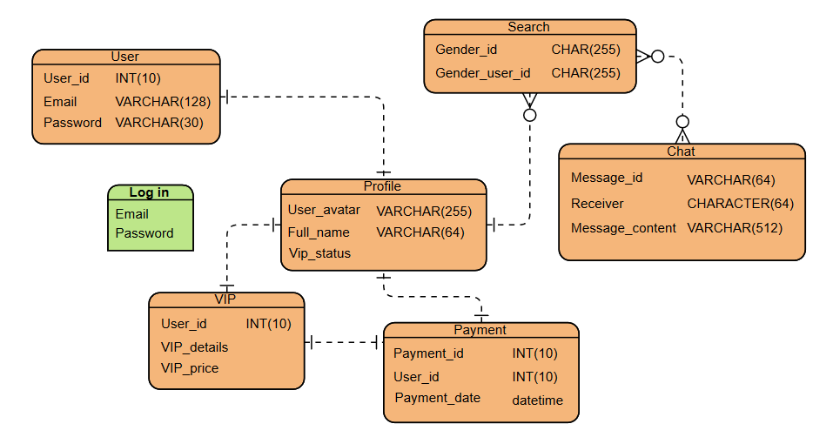

Start from sign up, new user can sign up using their email. All the attributes are required to fill in. Then, the user is successfully registered and officially become Chatty Chatty users. For user that already registered, they only need to sign in using their email and password. Users can edit their profile or account such as enter their full name and upload their pictures for easily get match from others user. Other than that, user can search people to chat. If the user is male, it automatically searching for female user and if the user female, they will find male user. However, the chat is limited for free user. They need to subscribed for VIP account for the unlimited chat in period of time depends on their subscription. We as the developer of Chatty Chatty, we hope users can found their spouse.